Delhi Bus Navigator for Application for Android Smartphone
Anuj Nagpal¹, Anirudh Pratap Singh²
Final Year Students of Department of Computer Science & Engineering,
Panipat Institute Of Engineering & Technology ,Panipat
anujnagpal19@gmail.com¹, anirudhpratap.singh57@gmail.com²
Abstract People love to travel places around. Whenever they get time, they visit the neighborhood, some heritage point, educational places, historical places, amusement parks etc.The problem arises are, where to go? When to go? What is the specialty of that particular place? How to reach there? What all other facilities are available in the nearby area? Most of the times these questions remain answerless.While planning for outing, deciding where to go is the first and the toughest part of the planning. Sometimes you get the answer and sometimes you don’t. Also there is a situation when you are deciding, thoughts occur, is it appropriate to visit that place, today?And Their a problem arise to where to go and how to go ,Sometime it is more difficult to know destination route for local people through Bus so finding Bus number to go destination place .If you ask people but it is not sufficient that information to want to go.Sometimes that person forgot about that information told by another person .The information you need to have is the historic value or USP of the place you are deciding to visit. Best commutation facility, how to reach there.
Generally, you don’t get all these information at a single place. You have to google about the place, read some blogs about the reviews and description of that place. Doing such things make it messy and consumes a lot of time to actually know the facts. People demand a solution to these multiple sources of information. They need a single platform to have all such information there, together and organized.Also they need is that the information should be handy and not to be vague. The information should be easily portable form place to place. And carrying that information should not look awkward.

Keywords: GPS, Google Maps, JVM.

1. Introduction

Android has become very popular in the world since it is an open source and there are no extra fees for Java Virtual Machine (JVM). In today‟s world, the time is more important for students. Being a product of high technology, mobile phones are more widely used and are becoming more and more popular. A vehicle tracking system is a commonly used application for tracking vehicles. Due to traffic congestion and road works, most of the buses are delayed. People have to wait for their bus at the bus stops for a long time without even knowing when the bus will arrive. Thus, the arrival time of the bus cannot be guaranteed. The main focus of the project is to save the waiting time of students and provide them the details of the bus.

2. Literature Survey

Dynamic Bus Time-table Using GPS [1] is a GPS based and manual system designed to display the real-time location and timetable of buses which can be useful for any public transport system. The system requires working internet connection and may or may not be GPS tracker.

Bus Locator via SMS using Android Application [2] uploads the current location of the bus to the server. The server then sends an SMS to all the registered students those are about to board at the bus stop. Here the driver‟s mobile phone is used as a GPS receiver. It is a tiresome process where the details of all the students are to be kept and updated time to time. The server is overloaded every now and then to get details of student at every stop.

Real time Bus Monitoring System using GPS [3] displays the current locations of the bus. The system consisted of a transmitter installed on the buses and receiver boards installed on the bus stops. It provided the relevant bus routes and other information their clients.

Real Time Web Based Bus Tracking System [9] provides the relevant information regarding all the bus going from user‟s source to destination. The system is operated by GPS which is

attached with every bus. It uses external hardware set-up for its implementation.

3. Android

Android is an open source and Linux based operating system for smart phones, tablet computers and android wearable devices like watches. It is developed by Google and later the OHA (Open Handset Alliance. The main focus of android project is to create a fruitful real-world product that enhances the mobile experience for users. ^{[11]}
The important features of android are given below:

  - Open Source

  - Easy to customize the Android Platform.

  - A lot of mobile applications can be chosen by the customer.

  - Provides many appealing features like weather details, opening screen, live RSS (Really Simple Syndication) feeds etc.

  - Provides support for messaging services(SMS and MMS), web browser, storage (SQLite), connectivity (GSM, CDMA, Blue Tooth, Wi-Fi etc.), media, handset layout etc.

- Proposed System

The proposed system provides the exact location of the bus to the students and staffs from their location. Along with this, it also provides the following features:
- To provide better service to the users.
- To share information regarding latest happenings at that place.
- The time and money of the users is saved.
- To provide users a platform to access data in a fast and easy way.
- To let user know the specialty of the place.

Anuj Nagpal , Anirudh Pratap Singh

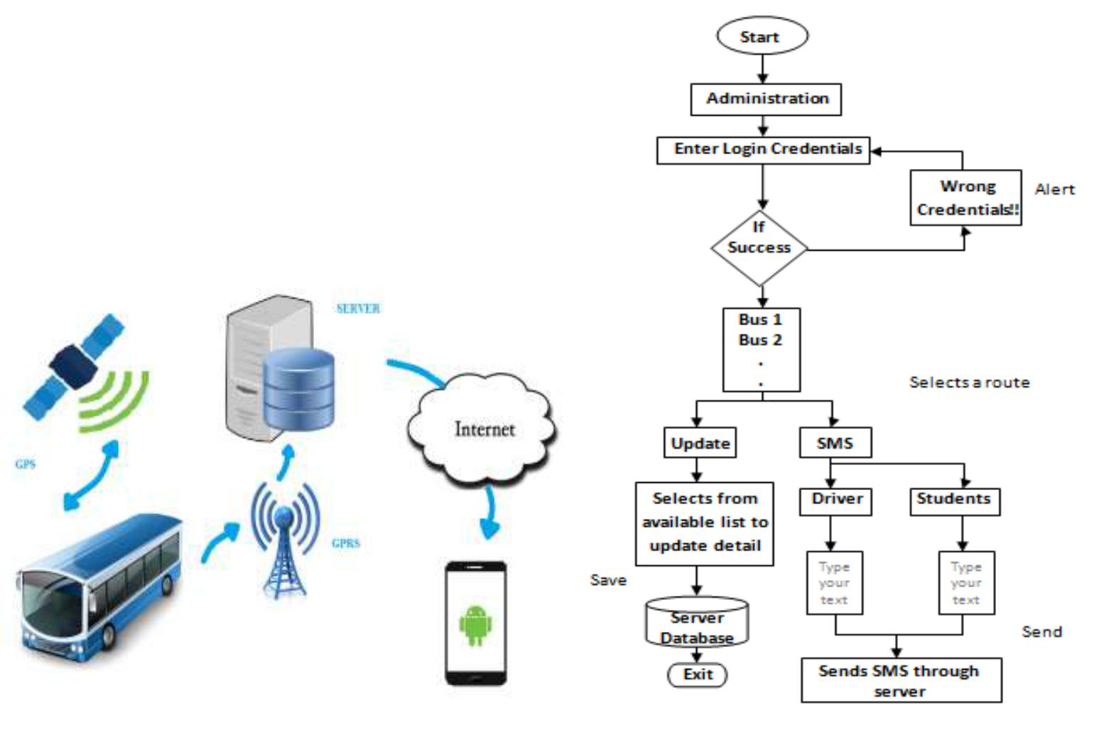

5. System Description

5.1 System Architecture

There are three modules in our application:

- Find Bus

- Find Route

- Find Stop

Figure 1: System Architecture

5.2 Modules Description

1) Find Bus:

This module is for the bus administrator for updating the information that is there in the server when required. It includes authority to update Driver name, Driver Contact Number, Route, Stops, etc. The administrator needs to log in before editing or updating details. Only administrator is the authorized user of this module. The administrator has been given a privilege of sending text messages to bus drivers and to the students of a particular route. It won‟t be charged to the administrator provided that his internet connection is in enabled mode. We are using way2sms services to accomplish this.

The following figure shows the flow of this module.

Figure 2: Flow Diagram for Administration Module

When Administrator enters into the Administration module, following screen will be provided for him to enter login credentials.
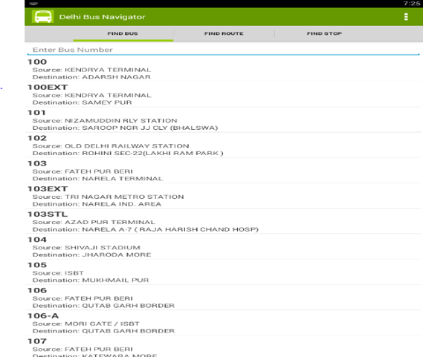

Figure 3: Administration Login Page

2) Find Route

This module is for the bus driver. The authorized bus drivers

are provided with their unique log in credentials. They need to

log in and then have to start their location service before

driving. The current location of the bus will be updated from

driver‟s mobile to the server every moment in the form of

Anuj Nagpal, Anirudh Pratap Singh

latitude and longitude. The location of the bus is visible in Google Maps when asked for.

The following figure shows the flow of this module.
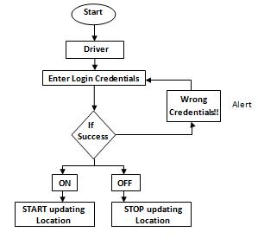

them to manage their time and arrive at their stop at the proper time, neither too early nor late.

The following figure shows the flow of this module.
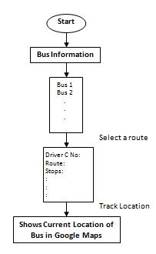

Figure 4: Flow Diagram for Driver Module

When Driver enters into the Driver module, following screen will be provided for him to enter login credentials.

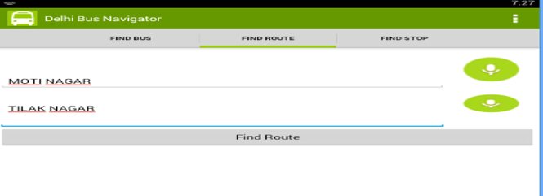

3) Bus Information:

This is the most important module and is the whole and soul of the system. The users of this module need to log in with their unique ID provided by the college management. They can get access to the details of all the buses of college through their phones. Here they will get all bus and driver related information offline too. Students can track the location of their bus from any location. Student and staff must make sure that their location service is active. The can also get the estimated time of arrival of bus at their respective stops. This will help

Figure 6: Flow Diagram for Bus Information Module

When Student or Staff enters into this module, they need to enter their credentials and after successful log in they will get the following screen to view bus details.

6. Future Enhancement

The following features can be added up as future enhancements:

- A feature can be added for parents, where they could be given a privilege of receiving a text message that their ward had board the bus safely as soon as they get into the bus.

Anuj Nagpal , Anirudh Pratap Singh

  - Managing of public transports likes auto-rickshaws and trains

- Conclusion

We developed an Android Application to track the college buses and provide relevant information to their users. This paper has described the design and architecture of our college bus tracking system. Our system is composed of smart phones and a server. The system is able to demonstrate its performance to track college bus from any area. Furthermore, our system is low-cost as it doesn‟t require any external hardware for location tracking.

- Manini Kumbhar, Meghana Survase, Pratibha Mastud, Avdhut Salunke,Shrinivas Sirdeshpande, “Real Time Web Based Bus Tracking System” International Research Journal of Engineering and Technology (IRJET), e-ISSN: 2395 -0056 Volume: 03 Issue: Feb-2016.

- Mr. Pradip Suresh Mane, Prof. Vaishali Khairnar, “Analysis of Bus Tracking System Using Gps on Smart Phones” IOSR Journal of Computer Engineering (IOSR-JCE) , ISSN: 2347–8586, Vol.3, Issue 3, 2015, Page.1057-1061.

- Javapoint.com, „What is Android‟ 2012. [Online].

Available:http://www.javatpoint.com/android-what-

where-and-why. [Accessed: 23- Jun- 2014].

Acknowledgement

We would like to express our intense honor and deep regard to

our project guide Asst. Prof. Rahul Kaushal for his guidance

and constant encouragement for carrying out the project.

Working under him was a great experience for us. He kept us

going, and this would not have been possible without him.

References

- Gunjal Sunil N. , Joshi Ajinkya V. , Gosavi Swapnil C. , Kshirsagar Vyanktesh B, “Dynamic Bus Timetable Using GPS” International Journal of Advanced Research in

Computer Engineering & Technology (IJARCET) , ISSN :2278-1323, Volume 3, Issue 3, March 2014.

- Karan Punjabi, Pooja Bolaj, Pratibha Mantur, Sneha

Wali, “Bus Locator via SMS Using Android Application”

International Journal of Computer Science and Information Technologies (IJCSIT) , ISSN :0975-9646, Volume 5(2), 2014.

- Dr.(Mrs.) Saylee Gharge, Manal Chhaya, Gaurav

Chheda, Jitesh Deshpande, Niket Gajra, “Real Time Bus Monitoring System Using GPS” Engineering Science and

Technology: An International Journal (ESTIJ), ISSN: 2250-3498, Volume 2, Number 3, June 2012.

- Amol Dhumal, Amol Naikoji, Yutika Patwa, Manali Shilimkar, Prof. M. K. Nighot, “Survey Paper on Vehicle Tracking System using GPS and Android” International

Journal of Advanced Research in Computer Engineering

- Technology (IJARCET), ISSN: 2278 – 1323, Volume 3 Issue 11, November 2014.

[5] S. Priya , B. Prabhavathi, P. Shanmuga Priya , B.

Shanthini, “An Android Application for Tracking College

Bus Using Google Map” International Journal of

Computer Science and Engineering Communications,

ISSN: 2347–8586, Vol.3, Issue 3, 2015, Page.1057-1061.

- G. Kiran Kumar, C.B. Aishwarya, A. Sai Mounika,

“College Bus Tracking Android Application using GPS”

International Journal of New Innovations in Engineering and Technology, ISSN: 2319-6319, Volume 4, Issue 4, April 2016.

- G. Jemilda, R. Bala Krishnan, B. Johnson, G. Linga

Sangeeth, “Mobile Application for College Bus Tracking”

International Journal of Computer Science and Mobile Computing, ISSN: 2320-088X, Volume 4, Issue 3, March 2015.

- SeokJu Lee, Girma Tewolde, Jaerock Kwon, “Design and

Implementation of Vehicle Tracking System Using GPS/GSM/GPRS Technology and Smart Phone

Application”IEEE World Forum of Internet of

Things(WF-IoT), March 2014.

Anuj Nagpal , Anirudh Pratap Singh

